AIPG MN Section – Annual Meeting Minutes
December 6, 2022 (1:15 PM to 3:15 PM Central)
Microsoft Teams
Meeting Prep: Review agenda, review 2021 meeting minutes for approval, and submit your reports on your committees and initiatives.
Meeting Purpose: Discuss future activities, talks, and progress with various initiatives, and discuss requests from the committee members or section members.
EXECUTIVE COMMITTEE |  |  |  | COMMITTEE CHAIRS
President |  | President Elect |  | Education Chair |  | Fundraising Chair |  | DEI Chair
X | Ben Czeck | X | Ben Czeck | X | Bruce Johnson | X | Curtis Hudak | X | Dan Hunter
Vice President |  | Secretary |  | Membership Chair |  | Reg & Leg Chair |  | Screening Chair
X | Marian Kramer | X | Miller Gruenewald | X | Paula Berger | X | Keith Rapp |  | Unappointed
Treasurer |  | Past-President/Director |  | Webmasters |  |  |  | Nominating Chair
X | Rebecca Ryser | X | Dan Hunter | X | Shanna Schmitt | X | Jake Dalbec |  | Unappointed
Directors
X | Alex Blel | X | Patrick Sweeney
 | Lauren Larkin |  | John Berger
X | Jeffrey Neisse
Do we meet have a quorum (at least 10% or 15 voting members) for this meeting?
X | Yes |  | No

Appointments:
State Mapping Advisory Committee, AIPG Member: Jake Dalbec, PG

Other positions, not appointed by AIPG MN Section:
AELSLAGID Joint Practice Committee, AIPG Member: Bruce Johnson, PG, CPG AELSLAGID Board Member, Geology, PG Member: Keith Rapp, PG, CPG ASBOG Board: Keith Rapp, PG, CPG
ASBOG Members-at-large: Bruce Johnson, PG, CPG and Shanna Schmitt, PG, CPG

Agenda

- Roll Call
  - We have enough ExComm Members and Committee Chairs for an official Annual Meeting

- Review and approve the 2021 Annual Meeting Minutes
  - https://aipgmn.org/Executive_Committee_Meeting_Minutes

  - Shanna made a motion to approve the 2021 Annual Meeting Minutes – No opposition, minutes are approved.

- Election Update
  - Still need candidates for multiple positions.
  - Once candidates are found for vacant positions, ballots will be sent out and voting will be open for two weeks.

- Officer and Committee Reports (2022 Officer and Committee Members reports included at the end of these Meeting Minutes)
  - President/President-Elect – Ben Czeck
  - Vice President – Marian Kramer
  - Treasurer – Rebecca Ryser
  - Secretary – Miller Gruenewald
  - Past-President/DEI Committee – Dan Hunter
  - Fundraising Chair – Curt Hudak
  - Education Chair – Bruce Johnson
  - Membership Chair – Paula Berger
  - Regulations & Legislative Chair – Keith Rapp
  - Screening Chair
  - Nominating Chair
  - Webmasters – Shanna Schmitt/Jake Dalbec
  - State Mapping Advisory Committee – Jake Dalbec

- Mineral Kit Donation for the Minnesota Minerals Education Workshop (MMEW)
  - Mike Hultgren updated Jake and Shanna.
    - A board meeting will be held December 13th, 2022.
    - We can continue to donate mineral hardness kits to teachers across the state.
    - Voting will be done at the next ExComm Meeting.

- Donation to Host Section for Annual Meeting
  - Will cover at next ExComm Meeting

- Sponsorship for Annual Meeting
  - Will cover at next ExComm Meeting

- New Appointments for 2023
  - Screening Chair – Typically only 1 or 2 CPG applications submitted in any given year (Dan Hunter considering taking ownership of this)
  - Membership Chair – TBD/Need Volunteer as of December 6, 2022 (Paula can temporarily stay on if needed)
  - Director #1/Past-President (Dan Hunter has volunteered for a second term as past president)
  - Director #2 (2023-2024 term), outgoing Director is Alex Blel (Alex agreed to serve another term)
  - Director #4 (2023-2024 term), outgoing Director is Lauren Larkin
  - Director #6 (2023-2024 term), outgoing Director is Jeffrey Neisse
  - Director 4 or 6 (2023-2024 term), Marian Kramer agreed to serve a term while supporting the VP responsibility hand-off

  - President-Elect – TBD/Need Volunteer as of December 6, 2022
  - Secretary – TBD/Need Volunteer as of December 6, 2022
  - Vice President – Jason Gelling
  - Treasurer – Rebecca Ryser
  - Webmaster – Jake Dalbec able to take over more in 2023

- Reply to AdHoc Education Committee, Minnesota Universities Discussion
  - Will need to pick this back up where we left off.
  - Waiting on a response for a discussion with professors. Need to follow up with professors to scheduled a meeting.

- AELSLAGID Board Geology Position (Expires 01/02/2023) – 4-year term, lifetime max is 2 terms
  - https://commissionsandappointments.sos.state.mn.us/Position/Details/425
  - Keith’s AELSLAGID Board position is posted at the above link.
  - Shanna will put together an announcement to send to APIG MN members to apply.
  - Typically, the Governor will ask for applications around the end of December.
  - AIPG ExComm has sent a recommendation letter on behalf of an AIPG member who has applied in the past.

Officer/Committee/Sub-Committee Annual Report
Name: Ben Czeck
Date: December 6, 2022
Position: President/President Elect and DEI Subcommittee
2022 Accomplishments/Activities/Duties: • Facilitated ExComm meetings
- Technical talk – AIPG MN Updates
- Interviewed three BIPOC Geoscience Professionals for a “Introduction to Geosciences” video to publish on the National AIPG YouTube Channel. The intention of the video is to help encourage/inspire BIPOC individuals to pursue the geoscience field by seeing BIPOC professionals doing amazing work. I’m finalizing edits and working to publish by the end of the year.
- Coordinated three joint AIPG and Minnesota Geotechnical Society awards and three Mortenson Environmental awards for the Minnesota Academy of Sciences annual Science Fair for middle and high school students. These awards were for the top 3 high school and middle school Geoscience, Environmental Science, or Sustainability Projects and included a certificate, fossil kit, mineral/rock specimen, and/or American Geosciences Institute Geoscience Handbook.
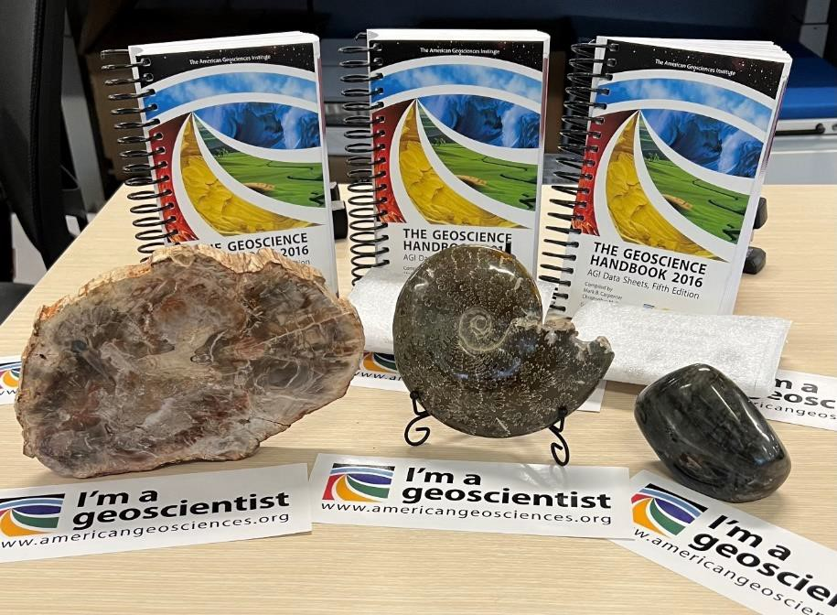

- Coordinated a joint MN/WI “Geology and Remediation Weekend” with technical talks and field trips in SE Minnesota/SW Wisconsin. This event helped create more collaboration between the two sections and is focused on bringing students, faculty, and professionals together.
  - St. Thomas brought their entire Geochemistry class and there were multiple student presenters.
  - Assisted Christine Lilek in drafting an article for TPG
- Drafted a letter of support to amend the Minnesota high school graduation requirements to include one credit of a dedicated earth and space science course and to secure funding for the Earth Science Teacher Education Program (ESTEP) to support our teachers.
- Attended a “Improving Geoscience Graduate Student Preparedness for the Future Workforce Workshop” at Stanford University sponsored by the National Science Foundation.
- Developed and taught an “Applied Environmental Policy” course at University of Saint Thomas in the Spring 2022.
Problems/Issues:
- Finding volunteers for AIPG officer/subcommittee positions.
- Student/Faculty engagement in the FG grants and scholarships.
- Resistance from University Faculty in AdHoc Education Committee Course Curriculum Letter
Suggestions for Improvement:
- Continue to develop tools/resources for the easy hand-off of roles and responsibilities for new Officers and Directors volunteering to support.
- Continue to re-establish student and professional social events to drive participation and engagement in in AIPG.
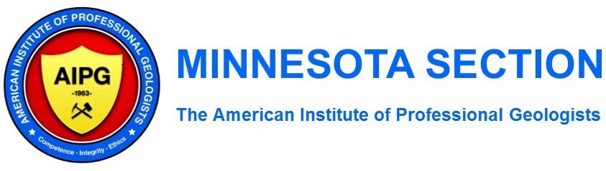

Officer/Committee/Sub-Committee Annual Report
Name: Rebecca Ryser
Date: December 6, 2022
Position: Treasurer
2022 Accomplishments/Activities/Duties:
Significant events for 2022 were a successful Golf Outing/bike ride in Stillwater, the MN/WI Geology Weekend, University of Minnesota Career fair, social events at Urban Growler and TopGolf, and the Fundamentals of Geology (FG) Exam grants, to name a few. Four grants were awarded to students to defray FG Exam fees, we sponsored science fair prizes (AGI Handbooks and fossils) for the Minnesota Academy of Science (MAS) Annual Science Fair and sponsored approximately 150 mineral kits for earth science teachers in Minnesota schools. We continued to host monthly virtual webinars and bi-monthly meetings.

Summary of Significant Expenses/Income:
The greatest expense for 2022 was the Golf Outing, however the event also generated approximately $4,880 in revenue. Other expenses included web fees, social events ($2,940), mineral kits ($2,400), one attendee for the AIPG National Conference ($1,090), a total of $800 in FG grants, one attendee for a National Science Foundation
(NSF) Workshop ($440), the MAS Annual Science Fair prizes ($300), and a $250 Sponsorship for the AIPG National Conference. The chapter received dues from National of $3,715. The monthly virtual talks also provided steady income throughout 2022 with the $5-10 fees per person. Our checking account started at $17,383.79 in January and is currently at $21,861.96. The certificate of deposit has hovered around $5,050 this year.

Problems/Issues:
There weren’t any major issues during 2022. It would be beneficial to acquire card readers for processing multiple payments during in person events when they become available. Our pay portal, StarChapter, has been working on this, but I haven’t seen news of the readers coming out yet.

Suggestions for Improvement:
Continue to work on more sponsorship and grant opportunities to support local geology students and the geologic community.

Name: Miller Gruenewald
Date: December 6, 2022
Position: Secretary
2022 Accomplishments/Activities/Duties: My main duty for 2022 was to take the minutes for Executive Committee Meetings. In addition, I uploaded to the draft meeting minutes to the AIPG Minnesota Section website for the rest of the Executive Committee to review and approve at future meetings.
Problems/Issues: Throughout 2022, draft meeting minutes from the previous meeting were not always approved.
While I like the option of having virtual monthly technical talks, it seems members of the AIPG MN section want some type of in-person technical talks to resume. Depending on occurrence and member interest, having in-person technical talks may not make financial sense.
Suggestions for Improvement: I think it would be beneficial for AIPG MN to hold more regularly occurring networking events to retain member engagement. I have also found the student/professional happy hours to be beneficial for all who attend.
Name: Daniel Hunter
Date: December 6, 2022
Position: Pasted President
2022 Accomplishments/Activities/Duties:
- Started the Diversity, Equity, and Inclusion Committee
- Got more involved with National Committees (National DEI Committee)
- Helped represent AIPG at the University of Minnesota Job Fair
- Worked on the 2022 Fall Field Trip Committee
Problems/Issues:
- The main problem we seem to have as an organization is getting new people to join the Executive Committee and volunteer for committees and other positions (President, Vice President, etc.)
Suggestions for Improvement:
- Continue to encourage young professionals and students to join AIPG.
- Encourage members to take part in the organization in committees.
- Continue working with the Wisconsin Section of AIPG to do join Field trips and other events.
- Reach out to Universities in Iowa and talk with their Geology Departments and students about AIPG and what we have to offer too them.

Name: Daniel Hunter
Date: December 6, 2022
Position: DEI Committee Chair
2022 Accomplishments/Activities/Duties:
- Started the DEI Committee
- We have added a DEI Moment to start our monthly meetings.
- We are working different ideas to added more DEI based activities. If you have any suggestion or ideas, please contact me.
Problems/Issues:
- Attendance at the DEI meetings have been only a few people do to time of the meetings and conflicts with the meeting time. If anyone has a good suggestion(s) for a better time for the meeting that would make it easier for people to attend the meetings, I would greatly appreciate their suggestions.
- Finding people to volunteer to give the DEI Moment at a monthly meeting. If you are interested and/or are willing to do a DEI Moment for a monthly meeting please let me know.
Suggestions for Improvement:
- Continue with the Monthly Meeting DEI Moments
- Work with the committee members to come up with more ways to educate Geoscientist on DEI.
- Possible of offering DEI Training to our members that are interested.

Officer/Committee Annual Report
Name: Fundraising Annual Report
Date: December 6, 2022
Position: Curtis M. Hudak, Fundraiser Chair
2022 Accomplishments/Activities/Duties: The AIPG Minnesota Section held its 2022 annual golf fundraiser on June 6th at the Stillwater Country Club in Stillwater, MN. Forty-seven golfers (47) attended this year, which is up from 39 golfers in 2021. We had witnessed a steady upward trend in the number of golfers each year since 2014 (see Table 1 below) until the Covid pandemic hit in 2020 and lingered a bit in 2021. The bounce back in attendees was nice to see. In addition to our 2022 golf participants, 11 non-golfers attended the auction/dinner after the golf event, which is up from 7 in 2021 and about the same as the 12 non-golfers in 2019. Overall, the dinner/auction event went up to 58 total participants from 46 in 2021 and down from 70 in 2019. This year’s nongolfer attendance was still up from the 2014-2017 trends that ranged from 5 to 8 non-golfers. Two of the 11 nongolfers were auction item winners, 2 were donors, indicating that the non-golfer attendees remain fairly active participants. The 58 total people amounted to our third highest attendee numbers since we reinitiated the golf fundraiser in 2014, when 2014 witnessed our lowest participation at 43 total people. We heard many positive comments on the quality of golf at the Stillwater Country Club.

Table 1
Year | 2022 | 2021 | 2020 | 2019 | 2018 | 2017 | 2016 | 2015 | 2014
Golfers | 47 | 39 | N/A | 58 | 48 | 46 | 44 | 42 | 38
Non-Golfers | 11 | 7 |  | 12 | 14 | 7 | 5 | 8 | 5
Total Diners | 58 | 46 |  | 70 | 62 | 53 | 49 | 50 | 43

The 2022 golf fundraiser brought in a similar number of auction items as in 2021, yet we delivered a profit a higher bid of $1,277.00 vs. only $819.00 in 2021. We only had one auction item worthy of a live auction, the other lesser auction items were all part of our silent auction. The largest auction income amount was $550 for a foursome of golf at the Stillwater Country Club donated by our hosts at the Country Club (live auction) and was one of five auction items that sold for more than $100.

Summary of Significant Expenses/Income
Table 2 below summarizes the net income and expenses. Table 2
Profit Calculation
Income =  Expenses = | $10,102.00
Income =  Expenses = | $5,225.63
Net Income = | $4,876.37

Moving our event to the Stillwater Country Club allowed us to maintain our costs at a bargain rate of $75/golfer ($5.00 more than in 2021) for one of the higher rated golf courses in the Twin Cities area. The SCC Bar & Grill staff worked with us to customize a new breakfast snack and lunch menu to keep the food costs at exactly $25.00 per golfer, which was a $2 decline in prices from 2021’s per golfer food costs. We heard positive comments from the diners on the selection of food and available beverages. This year featured a “Hot Dog, Brat, Burger, and Fish Sandwich” buffet.

Table 3 summarizes the trend of both expenses and net profit for the golf fundraiser.
Table 3
Year | 2022 | 2021 | 2019 | 2018 | 2017 | 2016 | 2015 | 2014
Total Income | $10,102.00 | $7,586.00 | $12,285.00 | $10,111.00 | $8,540.00 | $8,198.00 | $7,890.00 | $6,195.00
Eagle Card  Income*** | $975.00 | $700.00 | $1,450.00 | $1,000.00 | $975.00 | $660.00 | $860.00 | $700.00
Silent Auction  Income | $727.00 | $594.00 | $1,840.00 | $1,631.00 | $1,195.00 | $1,104.00 | $1,280.00 | $690.00
Live Auction | $550.00 | $225.00 | $1,020.00 | $850.00 | $345.00 | 0 | $200.00 | n/a
Total Expenses | $5,225.63 | $4,788.03 | $6,603.54 | $5,566.84 | $4,653.29 | $5,181.70 | $3,959.31 | $3,855.79
Golf Course, Cart & Food | $4,940.00 | $4,574.55 | $6,313.95 | $5,291.83 | $4,431.20 | $4,423.43 | $3,861.56 | $3,586.21
PayPal Fees** | $285.63 | $213.48 | $289.59 | $275.01 | $222.09 | $194.69 | ? | $123.99
Member  Reimbursement  * |  |  |  |  |  | $563.58 | $97.75 | $145.59
Net Income  (Profit) | $4,876.37 | $2,797.97 | $5,681.47 | $4,544.16 | $3,886.71 | $3,016.30 | $3,930.69 | $2,339.21
***(increased Eagle Card from $20 to $25 in 2017)
**(rounding errors from PayPal calculations; didn’t keep separate track of our PayPal costs in 2015, which was likely somewhere around $175-185, or roughly 2.0-2.3% of the Total Income)
*(2016 was the last year that AIPG-MN reimbursed our members for their purchasing of auction and supply items)

Note that our bottom line net income increased by $2,078.40 over the net income of 2021. This was approximately a 74% jump up in profits over 2021 and represented our second highest profit margin (only to 2019) since reinstating the golf event in 2014.

Sixteen door prizes were distributed to 16 different Eagle Card holders including one $100 Gift Card to Dick’s Sporting Good Store, and another approximately 20 golfers won team or hole prizes. This means that approximately 36 of 47 (~77%) unique golfers won at least one prize.

Problems/Issues:
Non-golfers were offered the Eagle Cards and all of them declined to make the $25 purchase. We may consider offering “Eagle Cards” to the non-golfers at a lower rate since they do not benefit from winning a golf club door prize or being entered into the hole prizes or using the card’s golf course mulligans.

We continue to see a climb in the use of PayPal versus the use of checks (see Table 3 above). Our range of PayPal fees has been somewhere between 2.0% and 2.5% of the Total Income for past fundraisers. This year was at 2.85% of the total income, or $285.63. Last year we saw our PayPal costs double to 4.45% of the total income.

Early warning signs are appearing that all local golf courses will be raising their rates next year because of cost of living adjustments to employee salaries and inflationary pressures on products.

Suggestions for Improvement:
- We may want to consider charging a surcharge on all PayPal/credit card charges. Many places of business are now surcharging approximately 4% for any credit card use, which will cover the most expensive of credit card user fees like AmEx at 3.5%. We are actively working to secure a 2023 fundraiser date and price with the Stillwater Country Club as soon as possible.

- Decide if a “door prize” card could be purchased for a different price by the non-golfers ($10-15/card?). The door prizes this year were almost entirely not golf-related. We also need to continue to keep the number of door prizes high, say more than 15, to keep the interest in these door prize cards.

- We need to continue to keep attracting more and better live and silent auction items, and sooner so that we may better advertise them well (several months at least) before the golf event. This might help to garner more proxy bids (we did have one proxy bid this year). More or higher-priced live auction items will be required to help stay the same or improve upon the auction revenue.

Summary:
We have been attempting to achieve a net income (profit) of approximately $100/golfer since we reinitiated the golf fundraiser in 2014. Our 2022 net income on a per golfer basis was $103.75/golfer, which is our best numbers ever since reinitiating the golf event in 2014. Compare that to the $71.74/golfer in 2021 or our previous all-time record of $97.96/golfer in 2019. Previous years’ high tallies were $94.67 per golfer in 2018, and $93.59/golfer in 2015. Other years were well below $80/golfer with 2014 and 2016 both being the lowest at $61.56/golfer. The Eagle Card has been a great success since we are pushing them harder than ever at a slightly increased rate and these dollars drop right to our bottom line. More door prizes are a necessity to keep us selling the Eagle Cards. We need to continue to keep attracting more and better auction items, and sooner in the year so that we may better advertise them well before the golf event. Early advertising helps to increase our numbers of golfers and non-golfers, which in turn might help to garner more and higher bids.

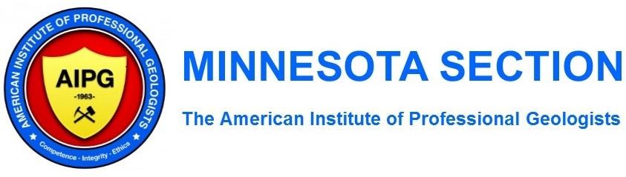

Officer/Committee Annual Report
Name: Paula Berger
Date: December 6, 2022
Position: Membership Committee Chair
2022 Accomplishments/Activities/Duties:
- Continued sponsorship program with annual sponsorships.
- Solicited 11 corporate sponsors for the 2022 calendar year (up from 9 in 2021).
- 2022 membership numbers not known. Based on previous data membership estimate is 185 total. • Minnesota Section membership is relatively steady. AIPG national membership is slowly declining.
Summary of Significant Expenses/Income • No expenses.
- Income of $250/sponsor. No change in sponsor amount
Problems/Issues:
- Corporate sponsorship was remains relatively constant – fluctuating up and down by one or two sponsors for the past several years.
- Anticipate less sponsorship in 2023 as some of the regular sponsor companies have combined. Suggestions for Improvement:
- None

Officer/Committee/Sub-Committee Annual Report
Name: | Keith B. Rapp
Date: | December 3, 2022
Position: | Regulation & Legislative Committee Chair

2022 Accomplishments/Activities/Duties:

The Regulation & Legislative Committee, in conjunction with committee member Bruce Johnson, have been preparing and discussing anticipated legislation to be introduced by the Minnesota Board of Architecture, Engineering, Land Surveying, Landscape Architecture, Geoscience and Interior Design (AELSLAGID), early in the 2023 Minnesota Legislative session. Language to be introduced pertaining to the profession of Geology includes admission to the FG and PG tests, language adopting the transition from paper to computer-based testing, Board Member qualifications, how board Orders are served, retroactive enforcement, comity applications, and defining ‘Applicants’.

The MN legislature gavels in Noon January 3, 2023, for a 120-day session.

Summary of Significant Expenses/Income:

There were no expenses or income associated with the Regulation & Legislative Committee in 2022.

Problems/Issues:

There were no substantive issues or problems encountered in 2022.

Suggestions for Improvement:

None at this time.

Officer/Committee/Sub-Committee Annual Report
Name: Jake Dalbec
Date: December 6, 2022
Position: Assistant Webmaster, State Mapping Advisory Committee (AIPG Rep.), DEI Committee Member
2022 Accomplishments/Activities/Duties:
- Actively participated in the MN Section of AIPG Executive Committee meetings and technical talks this past year.
- Assisted with Webmaster duties as requested by Shanna Schmitt (Webmaster) and as necessary.
- No annual State Mapping Advisory Committee (SMAC) occurred this year. Per Barbara Lusardi with the Minnesota Geological Survey via email: “USGS was extremely slow in getting out the new program announcement, so late, in fact, that we are not likely to even submit a proposal to STATEMAP this year. We already have plenty of projects to keep us busy. I still want to get the SMAC together to update everyone on our plans and progress.”
- Participated in several DEI Committee meetings led by Chairperson Dan Hunter resulting in great discussions and the start of a tradition in sharing DEI moments at the beginning of technical talks.
Summary of Significant Expenses/Income: None
Problems/Issues: The most glaring area for improvement continues to be related to recruitment, in opinion. Recruiting volunteers to run for officer election and be active on the Executive Committee continues to be a struggle. We have a great group of folks keeping the wheels turning for the MN Section of AIPG, but we need more. Our leaders are stretched thin. With Shanna now serving as AIPG’s National President-Elect
(congratulations Shanna!), we are going to need to bolster our efforts to recruit and spread-out duties more within our section, especially for the webmaster role in the coming years which has turned into a high responsibility role with much importance to the function of the section.
I would like to put more effort into helping with the DEI and Education Committee this upcoming year. There is opportunity to accomplish much more in both groups. It will be important to renew in-person educational presentations to k-12 students this upcoming year as well as solicit student grant/scholarship applications to ultimately award funds to a winner and put our educational funds to good use. This will likely involve the daunting task of restructuring our grant/scholarship program that has been on hold for several years now and may be negatively impacting our relationship with MN college and university geology professors.
Suggestions for Improvement:
- Acquire additional Microsoft Teams licenses for our Section to administer online meetings, technical talks and discussions.
- Continue to recruit geologists to be active in the MN Section of AIPG.
- Continue to recruit more MN Section of AIPG members to volunteer and run for office.
- Renew educational presentations to k-12 students with additional focus on DEI.
- Renew solicitation of student grant/scholarship applicants give out student grant(s)/scholarship(s).
- Improve relationship with MN college and university geology professors after MN Section of AIPG’s relationship was tarnished a bit due to suggested geology major curriculum improvements.

Officer/Committee/Sub-Committee Annual Report
Name: Shanna Schmitt
Date: December 6, 2022
Positions: Webmaster (with Jake Dalbec),
Student Grant Sub-Committee Chair,
Student Resume Review Sub-Committee Chair, and Social Sub-Committee Acting Chair
2022 Accomplishments/Activities/Duties: • Approved job postings – 38
- Draft/send Announcements – 15
- Website updates o Normal updates
- Website Stats o 16 documents uploaded to website o 85 emails sent o 33 events added to website o 643 orders through the website
- Each technical talk is advertised on our LinkedIn group page, the AIPG National LinkedIn group page, and our Facebook page. 11 social media (LI/FB) posts.
- Attended/sponsored the UMN TC department’s career fair on October 10, 2022
- Awarded FG Grants (all UMD students) in Spring 2022 o No applicants in Fall 2022
- Reviewed 22 resumes from UMN TC/Josh Feinberg’s course
- 2 social events, billed as student/professional socials – well attended
o 10/13/2022
o 4/26/2022
Summary of significant expenses/income:
Attendance | Revenue | Date | Meeting Name
38 | $230 | 1/4/2022 | AIPG MN Jan Meeting - Fargo-Moorhead Metro Project!
51 | $335 | 2/8/2022 | AIPG MN Feb Meeting - Vermillion Gold, Inc.'s Exploration Program for Orogenic Gold Deposits in Northern Minnesota's Vermilion Greenstone Belt!
109 | $1,910 | 3/15/2022 | AIPG MN Mar Meeting - AIPG Ethics Discussion Forum: Ethics, Diversity, and Unconscious Bias!
98 | $640 | 4/5/2022 | AIPG MN & AWG MN April Meeting - PFAS in Minnesota - What A Long Strange Trip It Still Is!
66 | $415 | 5/3/2022 | AIPG MN May Meeting - Record of an Ancient Meteorite Impact Buried Beneath the Twin Cities, MN!
15 | $65 | 6/1/2021 | AIPG MN June Meeting - Experimental Investigation of Mantle Heterogeneity!

41 | $260 | 9/13/2022 | AIPG MN Meeting - Strengthening The Geosciences Through Culture Change!
36 | $200 | 10/11/2022 | AIPG MN - Oct Meeting - Minneapolis SUHI: A Warm “Pool” of Groundwater Under the City
43 | $305 | 11/1/2022 | AIPG MN Nov Meeting - Databases & Data Tools - Approaches to Assembling & Using the Geological Data of MN!
41 | $270 | 12/6/2022 | AIPG MN Dec Meeting - The Red Wing Bridge Project - Floods, Faults and Frac Tanks!
538 | $4,630
53.8 | average attendance per meeting
$463 | average revenue per meeting
Problems/Issues:
- no FG grant applicants in Fall for 2 years.
- Need to rebrand the socials to drive professional attendance (maybe more of a sit down meal/event?)
Suggestions for Improvement:

